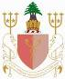
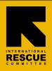

PUBLIC HEALTH IN COMPLEX EMERGENCIES (PHCE)

TRAINING PROGRAM PARTNERSHIP:

Faculty of Health Sciences, American University of Beirut, Lebanon
Public Health in Emergencies, Asian Disaster Preparedness Center, Thailand

School of Public Health, Makerere University, Uganda

With support from:

World Education, Inc. (WEI)

International Rescue Committee (IRC)

11th Course on Public Health In Complex Emergencies (PHCE-11)

2015 COURSE DATE and VENUE

16-28 March 2015: Asian Disaster Preparedness Center

Bangkok, Thailand

The Public Health in Complex Emergencies training program (PHCE) is a two-week intensive course that focuses on critical public health issues faced by NGO/PVO personnel working in complex emergencies. The goal of the course is to enhance the capacity of humanitarian assistance workers and their organizations to respond to the health needs of refugees and internally displaced persons affected by these emergencies. Participants will master key competencies in all of the following sectors:

Context of Emergencies Reproductive Health
Epidemiology Weapons, Violence and Trauma
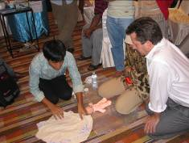
Communicable Disease Protection and Security
Environmental Health Psychosocial Issues
Nutrition Coordination

Who should take this course?
- NGO/PVO staff who are responsible now (or may be in the near future) for making decisions that affect the health of refugees and internally displaced persons.
- District medical officers and other Ministry of Health staff working in regions affected by complex emergencies.
- Staff from international and governmental organizations instrumental in planning services for people affected by complex emergencies.
- Medical Coordinators, Health Coordinators, Program Managers and District Medical Officers from international and national health organizations are typical candidates for the course.

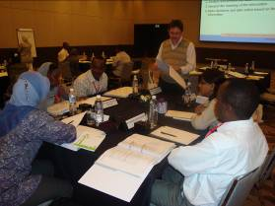
What makes this training program different?
Field staff from humanitarian, international and academic organizations have developed the curriculum specifically to meet the needs of NGO/PVO organizations working in complex emergencies. This course is truly “of the field, by the field and for the field.” Preference will be given to participants currently working in emergency situations.

Participants are expected to meet with their supervisors prior to attending the course to discuss an action plan for applying their new skills and knowledge. A structured exercise during the course will help to finalize these plans. Participants will be contacted months later and will be requested to report on their progress.

Who are the trainers?
The trainers are leading international and regional experts with a wide variety of field experience in complex emergencies. Trainers represent a range of backgrounds from NGO’s to multi-lateral organizations, international agencies, academic and research centers. They all have significant hands on experience and many have trained for many years in the Public Health in Complex Emergencies training program and/or were involved in designing the curriculum.
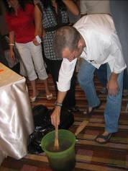

What is the cost?
- Course Package A US$2,575 without accommodation and breakfast
- Course Package B US$3,555 with accommodation and breakfast
- Both fees (A & B) cover the tuition fee, daily meeting package with lunch and refreshments, non-refundable registration fee of US$250, training kit and all course materials. Participants are also responsible for all of their travel expenses and incidentals such as medical insurance, laundry, personal phone calls, faxes, internet, and shipping of personal items from the course. Please refer to the Course Application Form for more details.

In the past, some participants have secured financial aid from ministries of health, UN agencies, donor organizations and private sources.

Course Accreditation
The PHCE Course has been accredited by the International Association of Emergency Managers (IAEM) Asia Council based in Singapore (http://www.iaem.com.sg) earning training credit towards the IAEM’s Certified Emergency Manager® credential as follows: 21 hours for Emergency Management and 4 hours for General Management with a total of 25 hours credit.

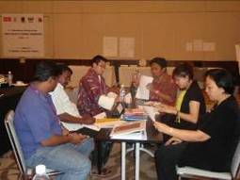
Language and teaching methods

The course is currently offered in English only. Extensive reading and participatory learning methods are used. Participants will receive pre-reading materials before arriving at the course site. An interactive simulation exercise on the last day gives participants an opportunity to use the skills and knowledge learned during the course. Participants should be fluent in reading and speaking English.

What is the application procedure?
It is best to apply electronically and email your applications to janette@adpc.net Applications should be submitted as soon as possible and the deadline for course registration/confirmation will be on 27 February 2015. Participants will be accepted on a rolling basis until the course is full. Course organizers will review applications and we will let you know as soon as possible if you have been accepted onto the course. Upon registration and receipt of payment, applicants will receive detailed information concerning pre-arrival preparation.

For further queries, please contact:  Janette Lauza-Ugsang  Senior Project Manager  Public Health in Emergencies  Asian Disaster Preparedness Center (ADPC)  979/69, 24th Floor, SM Tower  Samsen Nai, Phayathai Road, Bangkok 10400  Thailand  Tel: (66-2) 298-0681 ext. 404  Fax: (66-2) 298-0012 (Attn: PHCE)  E-mail: janette@adpc.net | Special acknowledgement and thanks to the following organizations:  Action Against Hunger, American University of Beirut (Lebanon), AMREF-Uganda, American Red Cross, American Refugee Committee, Asian Disaster Preparedness Center (Bangkok), CARE, Catholic Relief Services, Center for Culture, Ethnicity and Health (Australia), Columbia University Mailman School of Public Health, Doctors of the World, Institute of Public Health-Uganda, InterAction, International Aid, International Medical Corps, International  Rescue Committee, Mercy Corps, Macfarlane Burnet Centre for Medical Research (Melbourne, Australia), Medecins Sans Frontieres, MERLIN, Peace Corps, RedR, Relief International, Save the Children, Shoklo Malaria Research Unit, Transcultural Psychosocial Organization, United Nations High Commission for Refugees, U.S. Centers for Disease Control and Prevention, U.S. Office of Foreign Disaster Assistance/USAID, Women’s Commission for Refugee Women and Children, World Education, Inc., World Food Program, World Health Organization, World Vision

Thank you very much for your application and we will be in touch soon!
The PHE Course Management Team

