Regional Workshop
Flood Preparedness Programs in the Lower Mekong Basin
29 April 2008

IMPORTANT INFORMATION

Dear Sir/Madam,

Welcome to the Regional Workshop !

We are glad to share with you some general information on the regional workshop and logistic arrangements made for the smooth flow of this workshop.

Venue of the Workshop
The Workshop will be held at the Pailin Room , 11th Floor of the Windsor Suites Hotel. The address is: 8-10 Sukhumvit Soi 20, Sukhumvit Road, Bangkok
10110 Thailand, which is near to the Asok BTS (Sky Train) Station. The map of the venue is enclosed for your reference.

Registration
Registration will start at 08:00 am. Name badges and Workshop documents will be distributed to all participants during this time. We request you to kindly sign at the register and leave you name card (if possible) for updating our participant database.

Opening Ceremony
The Opening Ceremony will start at 08:30 am with speeches and remarks by Dr. Bhichit Rattakul, ADPC, Mr. Te Navuth, MRCS, Mr. Thanphong Bunyaratapan, DWR, Thailand and Ms. Cécile Pichon, Representative of European Commission Humanitarian Aid department (ECHO).

In addition, high level delegation representing key government officials of National Mekong Committees and National Disaster Management Offices from Cambodia, Lao PDR, Thailand and Vietnam would join the deliberations of the workshop.

A group photo will be taken immediately after the ceremony followed by a Coffee Break.

Presentations
A brief introduction of the MRC-ADPC Flood Preparedness Program project supported by ECHO would be presented. Session I : Experiences and Lessons Learned from Flood Preparedness and Emergency Management in the Lower Mekong Delta would have presentation from the MRC member countries on experiences in flood preparedness and strengthening emergency management. This session would be guided by the distinguished chairpersons. Presenters are requested to make their presentation for 15 minutes duration only. After the presentations, the Panel discussion on “Sustaining Flood Preparedness Program activities in the lower Mekong basin” would take place and we request for your valuable feedback and inputs.

The afternoon session would start with Session 2: Future Steps and Way Forward and expects to draw attention to MRC’s FMMP next steps and strategies to achieve its flood management and mitigation objectives.

The Group Discussion is the most important section of this workshop providing opportunity to brainstorm continuation and sustainability of flood management and mitigation activities in the MRC’s member countries and drawing lessons from other donor program activities in these countries. We would request you to kindly join the group which has been broken into member countries. Participants from donor organization, UN and NGOs from Bangkok office are requested to choose a country where they would like to make contribution.

Logistic Information

Lunch
As informed by the Venue, you can chose from a selection of buffet lunch options-
- International buffet lunch at Windsor cafe" restaurant/ Ground floor
- Dim sum buffet lunch at Golden Place Chinese restaurant / Pd floor
- Japanese buffet lunch at Yozen restaurant /Ground floor

Our project team would assist you at the lunch break.

Dinner
In honor of our distinguished guests from the member countries, the MRC-ADPC project team will host a dinner. Kindly submit your name to our workshop reception by lunch time enabling us to confirm the exact number to the Hotel.

Accommodation

Based on your arrival and departure information, we have already placed the list at the Reception with billing information.

Secretariat Contact Information

Ms. Poonyeanuch Kittiko of Windsor Suites Hotel would provide you all necessary information related to the venue, accommodation, lunch and dinner.

For any other assistance, kindly contact the MRC-ADPC Project Team;

- Ms. Thipsukhon (Khun Oat)
- Ms. Thitiphon (Khun Hope)
- Ms Miriam Roberts
- Mr. Aslam Perwaiz (Mobile 0816173710)
- Mr. Nguyen Huy Dzung

Kind regards,

The MRC-ADPC ECHO III Project Team

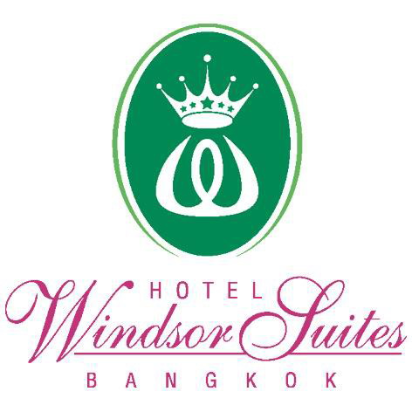
8-10 Sukhumvit Soi 20 Sukhumvit Road Bangkok
10110 Thailand

