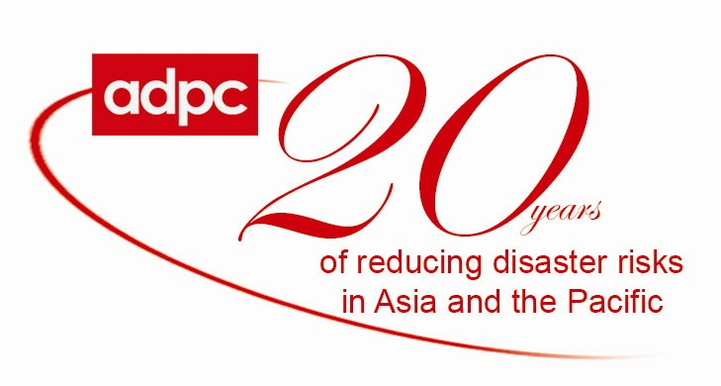

Meeting of the Regional Steering Committee of the Multi-hazard Early Warning System for Tsunami and Hydro-meteorological Hazards in Indian Ocean and Southeast Asia
Bangkok, Thailand
24-25 January 2008

The members of the Regional Steering Committee of the Multi-Hazard Early Warning System for Tsunami and Hydrometeorological Hazards in the Indian Ocean and Southeast Asia facilitated by ADPC will meet in Bangkok from 24-25 January 2008 with the following agenda:
- Review progress of the Regional Program Implementation Plan
- Present status of national early warning systems of participating countries
- Update the implementation plan for the next 6 months
- Develop a strategic plan to sustain Regional EWS operations

The Regional Steering Committee consists of national early warning focal points for both geological and hydro-meteorological hazards from the 14 countries. It was constituted in July 2006 to provide policy guidance, monitor, and evaluate the implementation of the ADPC-facilitated regional program on establishing end-to-end early warning for tsunamis and hydrometeorological hazards for disaster preparedness and mitigation in the two regions. UN agencies, namely the Intergovernmental Oceanographic Commission, World Meteorological Organization, and the UN Economic and Social Commission for Asia and the Pacific will also participate in the meeting.

15 January 2008

