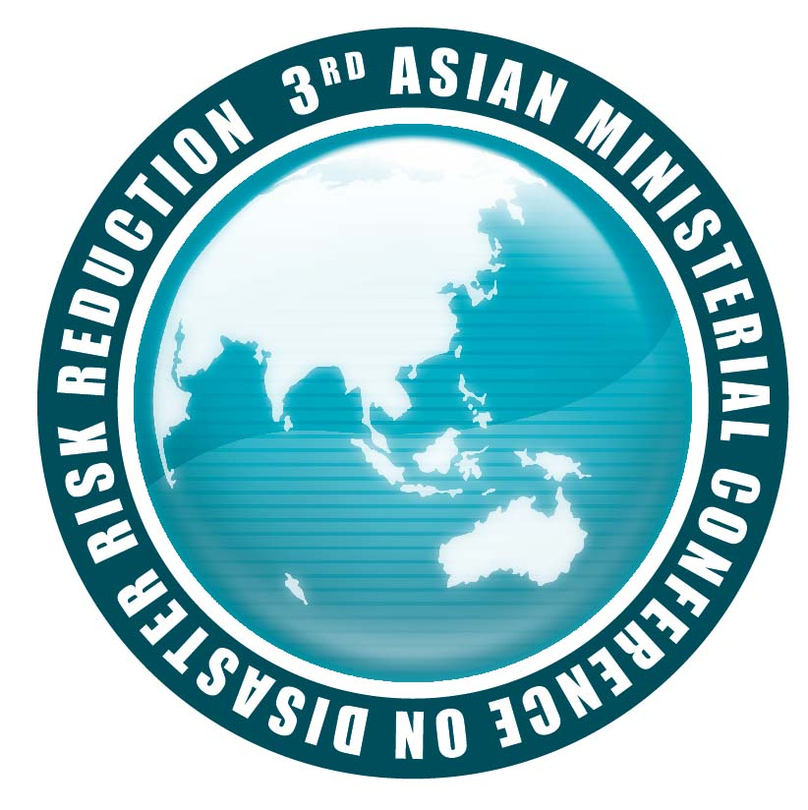
3rd Asian Ministerial Conference on Disaster Risk Reduction
2-4 December 2008 Kuala Lumpur, Malaysia

“Multi-stakeholder Partnership for Disaster Risk Reduction
From National to Local”

Concept Note

Side Event “F” | Mainstreaming Disaster Risk Reduction into Development; Experience of RCC MDRD Program
Schedule | 03 December 2003 (13 00 -14 30 hrs)
Theme to be addressed: | "Mainstreaming DRR into Development: Experiences and lessons learned from the RCC MDRD programme"
Organizers: | Session Leader: Asian Disaster Preparedness Center(ADPC) and United Nations Development Programme (UNDP)ITU
Background: | The Regional Consultative Committee (RCC) on Disaster Management is a regional mechanism comprising of 30 members from 26 Asian countries who are working in key Government positions in the National Disaster Management systems of countries of the Asian region. Countries include Afghanistan, Bangladesh Bhutan, Brunei, Cambodia, China, Georgia, India, Indonesia, Iran, Jordan, Kazakhstan, Korea, Lao PDR, Malaysia, Maldives, Mongolia, Myanmar, Nepal, Pakistan, Papua New Guinea, Philippines, Sri Lanka, Thailand, Timor Leste and Vietnam.  The RCC has been implementing the program on Mainstreaming Disaster Risk Reduction into Development (MDRD) since 2004 when the program was launched at the 4th meeting of the RCC in Dhaka. The RCC 5 adopted the Hanoi RCC 5 statement on Mainstreaming Disaster Risk Reduction in Development in Asian Countries. The program with a two track approach of mainstreaming disaster risk reduction into both national and sector development process had in its Phase I (2004-2007) initiated mainstreaming of disaster risk reduction in selected RCC member countries in sectors such as Education, Infrastructure (Roads), Local Government and Agriculture.  Learning from the experiences of the Phase I as well as from similar programs being implemented by the National Governments of the region, the program is currently in its Phase II and entitled “Partnerships for safe development and good governance”. The goal of the program is to promote Safe development and good governance in RCC member countries with increased community resilience to natural disasters; thus contribute to realizing the Millennium Development Goals by 2015 and advancing priorities of the Hyogo Framework for Action. In this phase the program is currently undertaking Priority Implementation Partnerships in Housing, Health, Education and Infrastructure sectors (Land use Planning), along with developing a RCC MDRD website to act as a knowledge management platform and a regional training course on mainstreaming of disaster risk reduction into development.  Being developed and implemented by the RCC member countries, the programs provides an opportunity to initiate mainstreaming in the country and which could later be up scaled by the existing national programs on disaster risk reduction or through sector development programs.
Session Objectives: | This side event is aimed to provide a venue to share experiences and lessons learned among the RCC member countries from the program till date; development of guidelines for mainstreaming of disaster risk reduction, undertaking priority implementation partnerships in RCC member countries, advocacy and knowledge management. It would also enable discussions among the members on the ongoing Phase II implementation and planned activities.
Speakers and title of their interventions | - Overview of RCC MDRD Program; approach, progress, future direction and partnerships; Mr. Loy Rego, ADPC  - Experiences and lessons learned from Priority Implementation Partnerships (PIP) of RCC MDRD Program on Mainstreaming DRR into National and Sectoral Development Planning and Implementation  - PIP on Mainstreaming DRR into National Development Planning in Nepal by Mr. Pratap Kumar Pathak, Ministry of Home Affairs, Nepal  - PIP on Mainstreaming DRR into Sectoral Development Planning in the Philippines by General Glenn Rabonza, National Disaster Coordinating Council, the Philippines  - PIP on Mainstreaming DRR into Housing Sector in Sri Lanka by Major General G. Hettiarachchi , Disaster Management Center, Ministry of Disaster Management and Human Rights  - Panel discussion on linking RCC MDRD Program with National DRR Programs and programs of other partners. Panel members would include:  - Mr. K.H. Masud Siddiqui, Disaster Management Bureau, Ministry of Food and Disaster Management, Bangladesh  - Dr. Ir Suprayoga Hadi, BAPPENAS, Government of Indonesia  - Mr. Saroj Jha, The World Bank
Possible Key recommendations | - Establishing strong linkage of the RCC MDRD Program with the ongoing/planned National program on disaster risk reduction and with national development programs.  - Involvement of National agencies of Planning and Finance  - Closer collaboration with development programs implemented with external funding from UN Agencies, bi lateral donors and IFIs.
Technical equipment required: LCD Projector, Screen for projection, Microphone

Note: The speakers of the session to be confirmed

