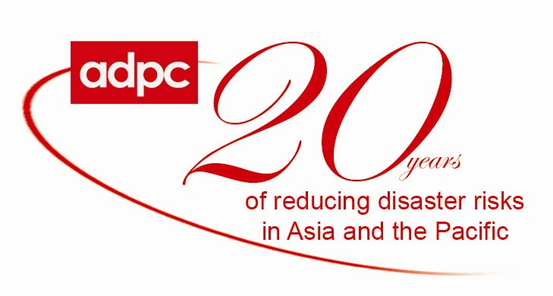

Questionnaire: Needs Assessment for a Course on Disaster Communications

Purpose:

There is an urgent need to understand the different concepts, facets, emerging trends, tools and techniques, and good practices broadly in the area of Disaster Communications and specifically, information & communications in Disaster Management. The role of information and communication plays a paramount role in disaster risk reduction (DRR), but it is evidently and visibly still a “grey” and fragmented area. In addition, the subject is also perceived differently by different people, with several specific areas of expertise, knowledge and understanding. The area is still evolving and topical, where ADPC as a pioneer organization in DRR intends facilitating and developing capacities through workshops and training.

This is an initial needs assessment questionnaire to assist in the development of a course in disaster communications. This questionnaire is designed to assess existing capacities and training needs of information & communication managers, specialists, public information personnel, disaster practitioners, reporting officials, and journalists working at different levels to effectively facilitate information management.

Name: ____________________________________________________________________________________
Key responsibilities: ________________________________________________________________________
Organization/Dept: ________________________________________________________________________
Email-Address: ____________________________________________________________________________
(Please answer the following questions in the space provided. Please use additional page if necessary)

- What aspects of Information and Communication in Disaster Management does your organization focus on?
Risk information communication Yes No_______________________________
Technology applications for disasters Yes No_______________________________
Information management tools Yes No ______________________________
Community Awareness Yes No_______________________________
Media Awareness Yes No ______________________________
Hardware/technology update & maintenance Yes No ______________________________
GIS and Remote Sensing Yes No ______________________________

Other aspects of Disaster Communications in Disaster Management (Please specify)
__________________________________________________________________________________________

- Has your staff/organization attended relevant/similar training courses in Disaster Communications in the past years? If yes, please provide brief information about training organization, duration, and expectations not met.

3. Will a program/training covering specific areas or in totality, mentioned in question 4 be of interest to you?

- Listed below are some focus areas under information and communication in disaster management. Which of these focus areas would be of interest to you/your organization, in terms of future training programmes?

- Communicating Disaster Risks
(Use of historical disaster information, early warning, behavioral change)
- Communication Channels
(Role of Media, Mass media, New Media, Reporting, Public Awareness, Ethics,
non-technology tools)
- Information & Communication Technology
(Technology for information generation & communications)
- Disaster Information Management Tools
(Database, Internet, Reporting Tools)

Any other, please specify: ___________________________________________________________________
__________________________________________________________________________________________
Thank you in advance for participating in this survey. Your information is valuable to us and will help contribute to assess the need and existing capacities of disaster communications. Please send your response to adpc@adpc.net or fax it to +66 2 524 5360.

