Institutionalising Sustainable CBDRM

Case Study Template
Community based disaster risk management (CBDRM) is a process in which at-risk communities are actively engaged in identifying and taking steps to reduce their vulnerability to disaster risk and build their capacities to manage them.
Asian Disaster Preparedness Center (ADPC) is an implementing partner for a 3-year programme looking at Institutionalising Sustainable Community Based Disaster Risk Management (CBDRM). The first phase involves collecting case studies of successful CBDRM initiatives to better understand the factors that need to be in place for community projects to be sustainable and replicated successfully elsewhere.
Your case studies will be compiled into a global and regional publication. As a result, this is an excellent opportunity to get your work published and gain international recognition for your work and the communities you work with. Some of the organisations that submit a case study will get invited to an international workshop to analyse the case studies to determine the critical factors for sustainable CBDRM. You could be one of them!
We also want to identify in which countries CBDRM has been institutionalised, or established as the norm.
If you have a case study of an example of CBDRM that you think other communities can learn from, please fill in this template and return to ADPC no later than January 29, 2018 through Mr. Irfan Maqbool (irfan@adpc.net), and Mr. Israel Jegillos (israel.j@adpc.net).

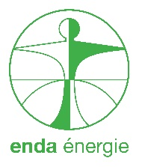
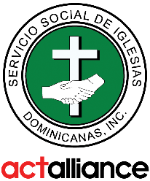
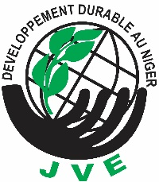
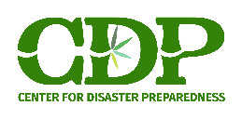

About your case study
Country
Community /
Case location
Name of your organisation
Your contact details
Do you have photos? | YES / NO
Title of Case Study
Click or tap here to enter text.

- The Activities
Please describe the CBDRM intervention, making sure you cover the following questions: Why did the CBDRM intervention take place? What were the activities? Who funded it? What other actors were involved? How long was the project for? When did it end? | Click or tap here to enter text.

- The Process
Tell us about the extent to which the CBDRM intervention was ‘owned’ by the community.  Were local skills and knowledge used?  What was the role of the local government?  How were the CBDRM activities coordinated? By whom? | Click or tap here to enter text.
To what extent were the most marginalised and at-risk groups included in the CBDRM process?  Focus on women, children and youth, the elderly, and persons with disabilities.  Are there any other marginalised groups in your society who were included in the CBDRM activities? | Click or tap here to enter text.
Were the CBDRM activities adjusted in any way to account for changing priorities and/or contexts in the community? If so, how? Think about mechanisms to monitor changes and learn from the activities, and who this monitoring and learning is coordinated by. | Click or tap here to enter text.

- The Impact
Please reflect on how well the initiative has been able to continue beyond the end of the programme. To what extent were local resources used for the CBDRM activities?  How long since programme completion have the CBDRM practices continued? | Click or tap here to enter text.
Please describe how lives have changed since the CBDRM project. Think about different people’s levels of resilience and vulnerability. | Click or tap here to enter text.

- Other
Please provide us with any other information you think will highlight the sustainability of your particular CBDRM project. Feel free to add relevant pictures, photos, graphs or anything else that may highlight the sustainability of your project. | Click or tap here to enter text.

[THE SECTION IN THE FOLLOWING PAGE ABOUT INSTITUTIONALISATION IS OPTIONAL]
>>>>

[OPTIONAL] Institutionalisation of CBDRM in your country
The following additional questions aim to gather information on the enabling environment for CBDRM in the country where your project was implemented. Please reflect to the best of your knowledge. If you’re not sure of anything, please say so.
- Policy environment
Is CBDRM adequately addressed in your country’s DRM and development-related laws, policies and plans? If yes (please list them), how are these being implemented at various levels?  Are the approaches standardised? Was your project able to influence any of these policies/laws?  Does your organisation have relationships with national structures like local or higher levels of government who can standardise locally validated CBDRM working principles? | Click or tap here to enter text.

- Structures and mechanisms
Who is responsible for coordinating CBDRM actions at the local level? Include reference to any functional committees, the role of local government, and whether your specific CBDRM project influenced the formation of these structures.  Is there enough provision (both technical and financial) for capacity building of CBDRM actors? If yes, please provide details on the frequency of capacity building activities, implementers and donors. | Click or tap here to enter text.

- Funding and incentives
Discuss the availability of long-term funding for CBDRM in different budgets.  To what extent do incentives and disincentives exist for CBDRM? Please provide any details, including reference to the continuity and diversification of funding. | Click or tap here to enter text.

- Culture and Practices
Please reflect upon whether your specific CBDRM project was able to influence any changes in local CBDRM culture or practices.  Is there a general recognition of the benefits of CBDRM by a) community members b) CSOs and c) the government? Is it included in mainstream discussion e.g. school curriculum or local development planning?  Do any feedback mechanisms exist through which local actors can influence local CBDRM policies? | Click or tap here to enter text.

- Other

Please provide us with any other information you think will highlight the institutionalisation of your particular CBDRM project.  Feel free to add relevant pictures, photos, graphs or anything else that may highlight the institutionalisation of your project. | Click or tap here to enter text.

